|  |  |  |  |  |
| --- | --- | --- | --- | --- |
|  |  | | |  |
| **Huawei vCenter Plug-in** | | |
| **User Guide** | | |
| **Issue** | **03** | |
| **Date** | **2018-08-29** | |
|  | | | | |
|  |  | |  |  |

Preface

Purpose

This document describes the installation and operation and maintenance (O&M) of the Huawei vCenter plug-in.

Intended Audience

This document is intended for:

* Technical support engineers
* System maintenance engineers

Symbol Conventions

The symbols that may be found in this document are defined as follows.

| Symbol | Description |
| --- | --- |
|  | Indicates an imminently hazardous situation which, if not avoided, will result in death or serious injury. |
|  | Indicates a potentially hazardous situation which, if not avoided, could result in death or serious injury. |
|  | Indicates a potentially hazardous situation which, if not avoided, may result in minor or moderate injury. |
|  | Indicates a potentially hazardous situation which, if not avoided, could result in equipment damage, data loss, performance deterioration, or unanticipated results.  NOTICE is used to address practices not related to personal injury. |
|  | Calls attention to important information, best practices, and tips.  NOTE is used to address information not related to personal injury, equipment damage, and environment deterioration. |

Change History

Changes between document issues are cumulative. The latest document issue contains all the changes made in earlier issues.

Issue 03 (2018-08-30)

Added 3.2.6 Receiving and Viewing Server Alarms.

Issue 02 (2018-06-29)

Added 3.2.5 Registering, Configuring, and Using Proactive HA.

Issue 01 (2017-09-29)

This issue is the first official release.

Contents

Preface ii

1 Overview 1

2 Installing and Uninstalling the Huawei vCenter Plug-in 3

2.1 Installing the Huawei vCenter Plug-in 3

2.2 Uninstalling the Huawei vCenter Plug-in 8

3 Operation and Maintenance 15

3.1 Configuring eSight 15

3.1.1 Adding eSight 15

3.1.2 Editing eSight 18

3.1.3 Deleting eSight 20

3.2 Managing Servers 20

3.2.1 Viewing the Server List 20

3.2.2 Deploying an OS 22

3.2.2.1 Adding a Software Source 22

3.2.2.2 Creating an OS Template 25

3.2.2.3 Creating a Template Task 27

3.2.3 Managing Templates 29

3.2.3.1 Configuring Power Control 29

3.2.3.2 Configuring the BIOS 30

3.2.3.3 Configuring an HBA 38

3.2.3.4 Configuring RAID 40

3.2.3.5 Configuring a CNA 42

3.2.3.6 Configuring the iBMC 45

3.2.4 Upgrading the Firmware and Driver 48

3.2.4.1 Uploading an Upgrade Package 48

3.2.4.2 Upgrading the Firmware and Driver 50

3.2.5 Registering, Configuring, and Using Proactive HA 52

3.2.5.1 Registering HA Provider 52

3.2.5.2 Configuring Proactive HA 54

3.2.5.3 Using Proactive HA 57

3.2.6 Receiving and Viewing Server Alarms 58

3.3 Viewing the Huawei vCenter Plug-in Version 61

# Overview

The Huawei vCenter plug-in is a plug-in integrated in the vCenter software and used for Huawei server management. By adding eSight, it can implement the OS deployment, server cnfiguration, upgrade, and monitoring functions on Huawei servers.

You can implement the following functions by using the Huawei vCenter plug-in:

* View server information and component information.
* Deploy server OSs in batches. Table 3-1 lists the OS types and versions that can be deployed.
* Configure CNAs, HBAs, BMCs, BIOSs, and RAIDs of servers.
* Upgrade server firmware and drivers.
* Provide Proactive HA Provider to implement isolation functions on abnormal servers.

The compatibility between the Huawei vCenter plug-in and vCenter software, and servers is as follows:

* The Huawei vCenter plug-in supports vCenter 6.0, vCenter 6.5, vCenter 6.7.0, and vCenter 6.7.c.
* Table 1-1 lists the servers supported by the Huawei vCenter plug-in.

Supported servers

| Type | Server |
| --- | --- |
| Rack server | RH2288H V2 |
| RH1288 V3 |
| RH2288 V3 |
| RH2288H V3 |
| RH5885 V3 |
| RH8100 V3 |
| 1288H V5 |
| 2288H V5 |
| 2488 V5 |
| Blade server | E9000 |
| High-density server | XH321 V3 |
| XH620 V3 |
| XH622 V3 |
| XH628 V3 |

# Installing and Uninstalling the Huawei vCenter Plug-in

2.1 Installing the Huawei vCenter Plug-in

2.2 Uninstalling the Huawei vCenter Plug-in

## Installing the Huawei vCenter Plug-in

Prerequisites

* JRE 1.8.0 or later has been installed on the server.
* You have obtained the Huawei vCenter plug-in installation package **vCenter-plugin-1.0.zip** and deployment program package **vcenter-deployer-1.0.jar**.

Hardware Requirements

Recommended configuration:

* CPU: 8 cores, 2 GHz
* Memory: 16 GB
* Hard disk: 500 GB

Procedure

Log in to the server as the administrator, and upload the Huawei vCenter plug-in installation package and deployment program package to the server.



The Huawei vCenter plug-in installation package and deployment program package must be stored in the same path.

Modify the Java environment variable.

Windows Server 2012 R2 is used as an example.

1. In **Control Panel**, choose **System and Security** > **System** > **Advanced system settings**.

The **System Properties** dialog box is displayed.

1. On the **Advanced** tab, click **Environment Variables**, as shown in Figure 2-1.

System Properties

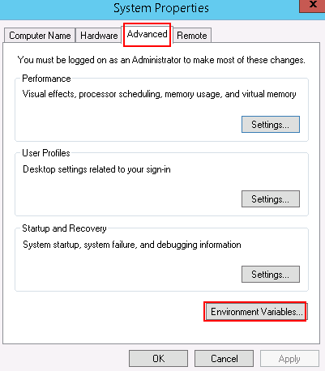

The **Environment Variables** dialog box is displayed.

1. In the **System variables** area, select the **Path** variable, and click **Edit**.

The **Edit System Variable** dialog box is displayed.

1. Add a variable value, and click **OK**.

For example, add **C:\Program Files\Java\jre1.8.0_121\bin** to **Variable value**, as shown in Figure 2-2.

Edit System Variable

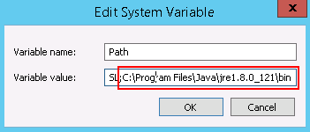

1. Click **OK**.
2. Click **Apply**, and click **OK**.
3. Run CMD to access the CLI, and enter java -version to view the JRE version.

Decompress the deployment program package.

Run CMD to access the CLI, and run the following command to go to the path for storing the software package and deployment program package:

**cd** *Path for storing the software package and deployment program package*

Run the following command to start the deployment program package:

**java -jar** *Deployment program package name***.jar**

If information shown in Figure 2-3 is displayed, the program deployment is complete.

Command output

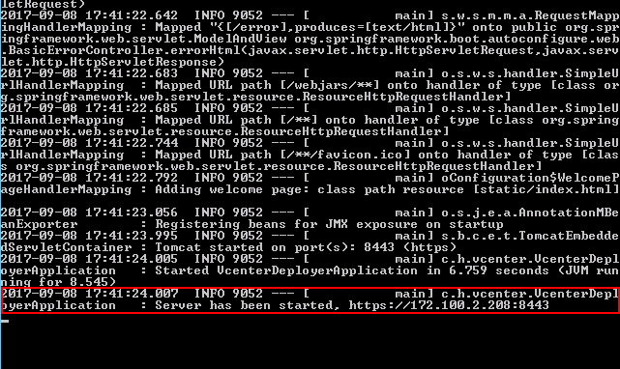

**8443** is the default port number. To change the port number, run the following command:

**java -jar** *Deployment program package name***.jar --server.port=***Customized port number*



When you perform the following operations for installing the Huawei vCenter plug-in, do not close the CLI; otherwise, the installation page cannot be opened.

Open the browser on the local PC, enter **https://*vCenter IP address*:8443** in the address box, and press **Enter**.

The **Huawei vCenter plugin update program** page is displayed, as shown in Figure 2-4.

Huawei vCenter plugin update program

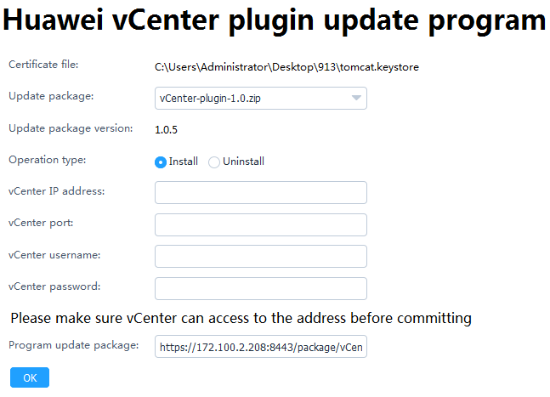

Set the following parameters, and click **OK**.

* **Update package**: Select the vCenter installation package.
* **Operation type**: Select **Install**.
* **vCenter IP address**: Enter the vCenter IP address.
* **vCenter port**: Enter the vCenter port number. The default value is **443**.
* **vCenter username**: Enter the vCenter administrator user name.
* **vCenter password**: Enter the vCenter administrator password.

In the server CLI, view the command output. If information shown in Figure 2-5 is displayed, the Huawei vCenter plug-in is successfully installed.

Command output

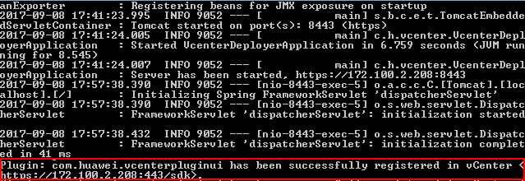

Open the browser on the local PC, enter **https://*vCenter IP address*** in the address box, and press **Enter**.

The vCenter login page is displayed.

Enter the user name and password for logging in to vCenter, and click **Login**.

The vCenter homepage is displayed.

If the icon in the red box shown in Figure 2-6 is displayed, the Huawei vCenter plug-in is successfully installed.

Homepage

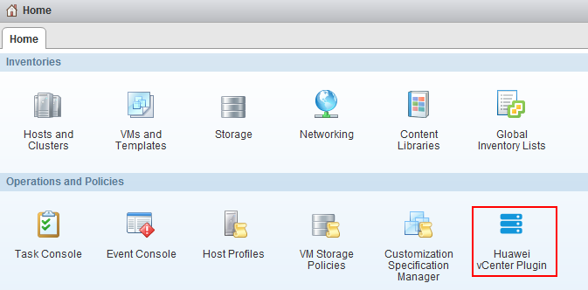

If you have logged in to vCenter, you need to log out and then log in again to view the Huawei vCenter plug-in icon. Then the plug-in takes effect.

----End

## Uninstalling the Huawei vCenter Plug-in

Prerequisites

* JDK 1.8.0 or later has been installed on the server.
* You have obtained the Huawei deployment program package **vcenter-deployer-1.0.jar**.

Procedure

Log in to the server as the administrator, and upload the Huawei deployment program package to the server.

Modify the Java environment variable.

Windows Server 2012 R2 is used as an example.

1. In **Control Panel**, choose **System and Security** > **System** > **Advanced system settings**.

The **System Properties** dialog box is displayed.

1. On the **Advanced** tab, click **Environment Variables**, as shown in Figure 2-7.

System Properties



The **Environment Variables** dialog box is displayed.

1. In the **System variables** area, select the **Path** variable, and click **Edit**.

The **Edit System Variable** dialog box is displayed.

1. Add a variable value, and click **OK**.

For example, add **C:\Program Files\Java\jre1.8.0_121\bin** to **Variable value**, as shown in Figure 2-8.

Edit System Variable



1. Click **OK**.
2. Click **Apply**, and click **OK**.
3. Run CMD to access the CLI, and enter java -version to view the JRE version.

Decompress the deployment program package.

Run CMD to access the CLI, and run the following command to go to the path for storing the deployment program package:

**cd** *Path for storing the deployment program package*

Run the following command to start the deployment program package:

**java -jar** *Deployment program package name***.jar**

If information shown in Figure 2-9 is displayed, the program deployment is complete.

Command output



**8443** is the default port number. To change the port number, run the following command:

**java -jar** *Deployment program package name***.jar --server.port=***Customized port number*



When you perform the following operations for uninstalling the Huawei vCenter plug-in, do not close the CLI; otherwise, the uninstallation page cannot be opened.

Open the browser on the local PC, enter **https://*vCenter IP address*:8443** in the address box, and press **Enter**.

The **Huawei vCenter plugin update program** page is displayed, as shown in Figure 2-10.

Huawei vCenter plugin update program

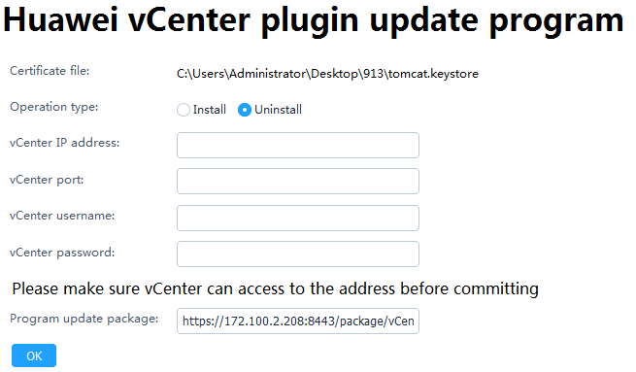

Set the following parameters, and click **OK**.

* **Operation type**: Select **Uninstall**.
* **vCenter IP address**: Enter the vCenter IP address.
* **vCenter port**: Enter the vCenter port number. The default value is **443**.
* **vCenter username**: Enter the vCenter administrator user name.
* **vCenter password**: Enter the vCenter administrator password.

In the server CLI, view the command output. If information shown in Figure 2-11 is displayed, the Huawei vCenter plug-in is successfully uninstalled.

Command output

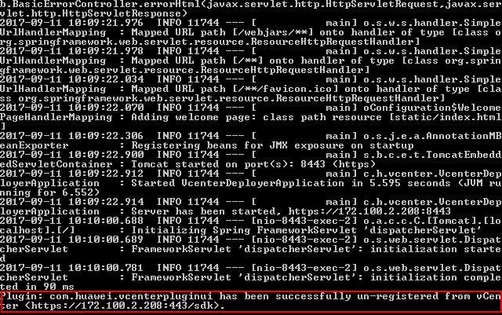

Open the browser on the local PC, enter **https://*vCenter IP address*** in the address box, and press **Enter**.

The vCenter login page is displayed.

Enter the user name and password for logging in to vCenter, and click **Login**.

On the vCenter homepage, check whether the plug-in icon is deleted.

* If yes, no further action is required.
* If no, perform Step 11 and Step 12 to clear the browser cache and open the browser again.

Clear the browser cache.

**Internet Explorer 11.0** is used as an example.

1. Select **Internet Options**.

The **Internet Options** dialog box is displayed.

1. Click **Delete**, as shown in Figure 2-12.

Internet Options

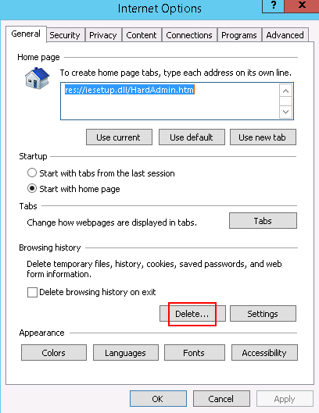

The **Delete Browsing History** dialog box is displayed.

1. Select the required items, and click **Delete**, as shown in Figure 2-13.

Delete Browsing History

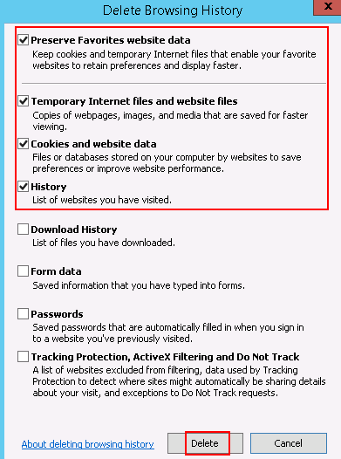

1. Click **Apply**, and click **OK**.

Open the browser again, log in to vCenter, and check whether the plug-in icon is deleted.

* If yes, no further action is required.
* If no, contact Huawei technical support.

----End

# Operation and Maintenance

3.1 Configuring eSight

3.2 Managing Servers

3.3 Viewing the Huawei vCenter Plug-in Version

## Configuring eSight

### Adding eSight

Set a whitelist.

By default, a whitelist of eSight northbound ports is configured. To add an eSight system properly, you must add the IP address of the server where vCenter is located to the whitelist of eSight northbound ports.

1. Log in to the eSight WebUI.
2. Choose **System** > **Northbound Integration** > **Third-party System** > **Create**.

The **Third-party System** page is displayed, as shown in Figure 3-1.

Third-party System

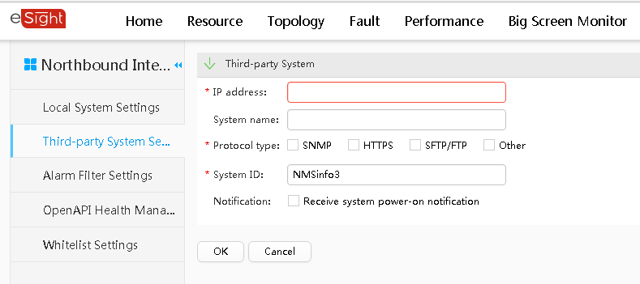

1. Set the following parameters:

* **IP address**: Set this parameter to the IP address of the server.
* **Protocol type**: Select **HTTPS**.
* **System ID**: Retain the default value or enter a new value. The value can be an IP address or a string of 1 to 64 characters, including digits (0-9), lowercase letters (a-z), uppercase letters (A-Z), and special characters @_- (), .^$~`!.

1. Click **OK**.

The IP address of the server is set as a whitelist, as shown in Figure 3-2.

Set successfully

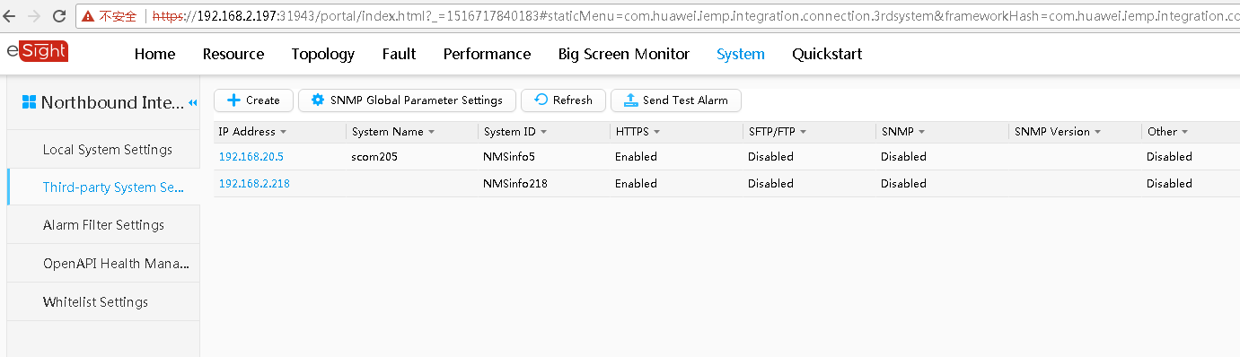

On the vCenter WebUI, choose **Home** > **Operations and Policies** > **Huawei vCenter Plugin**.

The **Huawei vCenter Plugin** page is displayed.

Select **eSight Set**.

The **eSight Set** page is displayed.

Click **Add eSight**.

The **Add eSight** dialog box is displayed.

Set the following parameters, and click **Test**, as shown in Figure 3-3.

Add eSight

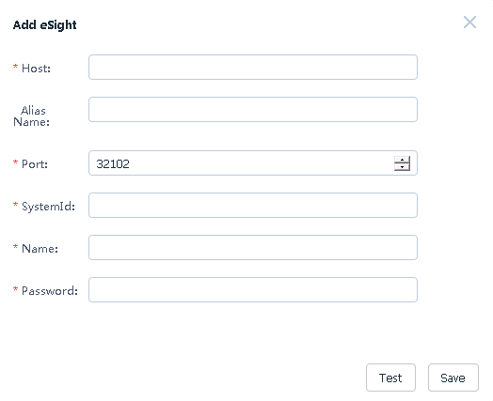

* **Host**: Enter the IP address of the eSight to be added.
* **Alias Name**: (Optional) Enter the customized name of the eSight to be added. This name is used to identify the eSight.
* **Port**: Enter the port number of the eSight to be added.
* **SystemId**: Enter a value that is the same as that of **System ID** in Step 1.3.
* **Name**: Enter the user name of the eSight to be added. The default user name is **openApiUser**.
* **Password**: Enter the password of the eSight to be added. The default password is **Huawei12#$**.

If the connection is successful, "Link test successfully" is displayed on the page. If the connection fails, "Link test failed: An error occurred when connecting to the eSight server." is displayed on the page. Modify parameters according to the error code, and test the connection again.

After the connection is successful, click **Save** to save the eSight configuration information.

The **Prompt** dialog box is displayed.

Click **OK**.

The eSight is added.

On the **eSight Set** page, view the added eSight, as shown in Figure 3-4.

eSight Set

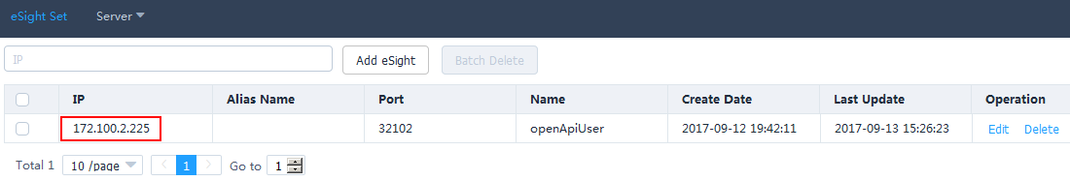

----End

### Editing eSight

On the vCenter WebUI, choose **Home** > **Operations and Policies** > **Huawei vCenter Plugin**.

The **Huawei vCenter Plugin** page is displayed.

Select **eSight Set**.

The **eSight Set** page is displayed.

In the row of the eSight to be edited, click **Edit**.

The **Edit eSight** dialog box is displayed.

Edit the following parameters, as shown in Figure 3-5.

Edit eSight

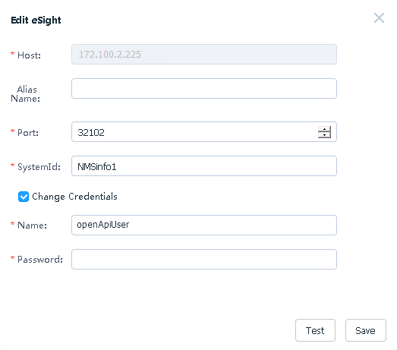

* **Alias Name**: Change the value to another one. This name is used to identify the eSight.
* **Port**: Change the eSight port number.
* **SystemId**: Enter a value that is the same as that of **System ID** in Step 1.3.
* **Change Credentials**: This parameter is deselected by default. You can change the eSight user name and password after this parameter is selected.
* **Name**: Change the eSight user name. The default user name is **openApiUser**.
* **Password**: Change the eSight password. The default password is **Huawei12#$**.



After eSight is accessed, if the eSight port number, user name, or password is changed, you must synchronize the new port number, user name, or password to the Huawei vCenter plug-in; otherwise, server management of the Huawei vCenter plug-in will be affected.

Check whether **Change Credentials** is selected and the user name or password is changed.

* If yes, click **Test**. After the connection is successful, click **Save** to save the eSight configuration information.
* If no, click **Save** to save the eSight configuration information.

The **Prompt** dialog box is displayed.

Click **OK**.

The eSight is edited.

On the **eSight Set** page, view the modified eSight, as shown in Figure 3-6.

eSight Set

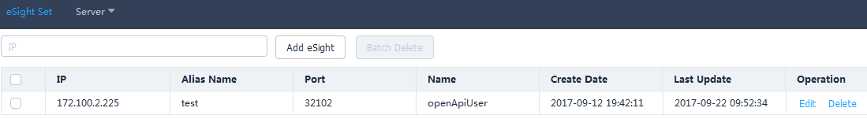

----End

### Deleting eSight

On the vCenter WebUI, choose **Home** > **Operations and Policies** > **Huawei vCenter Plugin**.

The **Huawei vCenter Plugin** page is displayed.

Select **eSight Set**.

The **eSight Set** page is displayed.

In the row of the eSight to be deleted, click **Delete**, as shown in Figure 3-7.

Deleting eSight

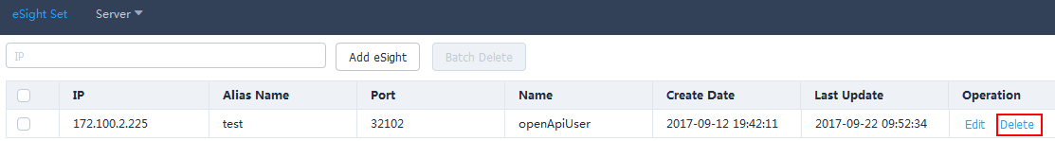

The **Prompt** dialog box is displayed.



To delete eSight systems in batches, select the eSight systems to be deleted, and click **Batch Delete**.

Click **OK**.

The eSight is deleted.

----End

## Managing Servers

### Viewing the Server List

On the vCenter WebUI, choose **Home** > **Operations and Policies** > **Huawei vCenter Plugin**.

The **Huawei vCenter Plugin** page is displayed.

Choose **Server** > **Server List**.

The **Server List** page is displayed.

Select **eSight Alias Name** and **Server Type**, and view the values of **IP Address**, **Name**, **Status**, and **Model** of the selected server type under the eSight, as shown in Figure 3-8.

Server list

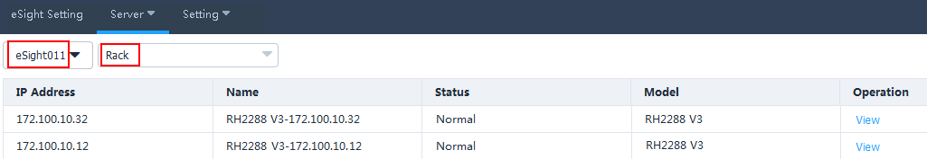

In the row of any server, click **View**.

View the basic information, online device status, and mainboard, CPU, memory, hard disk, PSU, fan, RAID, NIC, and PCIe information of the server, as shown in Figure 3-9.

Device status

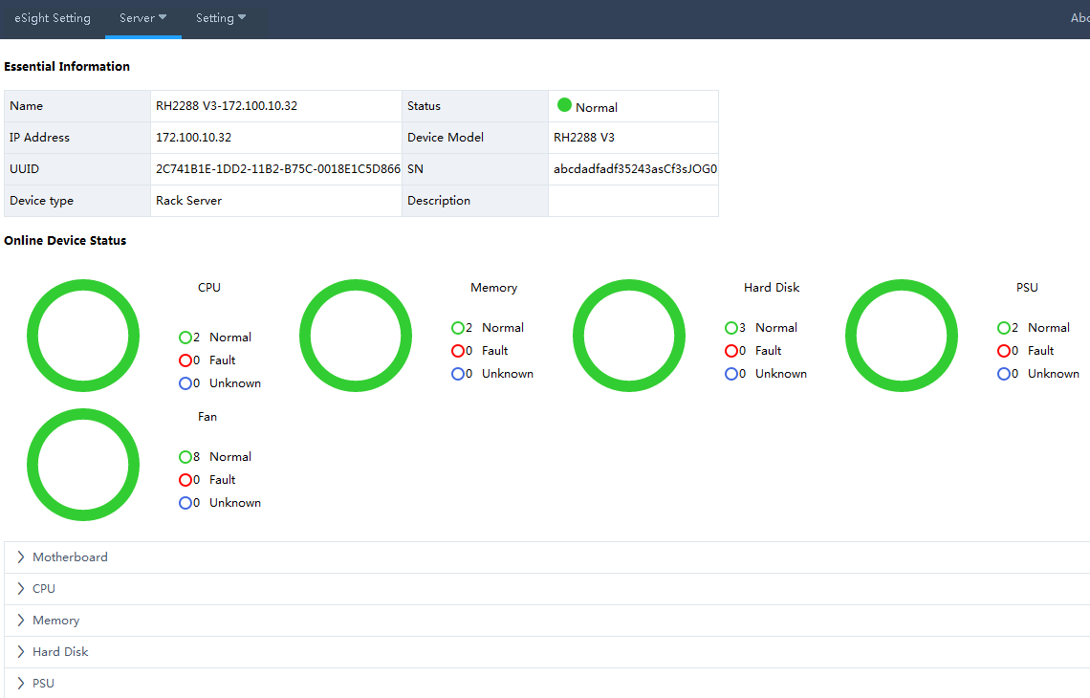

Click **Back**.

The **Server List** page is displayed.

----End

### Deploying an OS

#### Adding a Software Source

Upload the OS image file to be added to the Secure File Transfer Protocol (SFTP) server.

On the vCenter WebUI, choose **Home** > **Operations and Policies** > **Huawei vCenter Plugin**.

The **Huawei vCenter Plugin** page is displayed.

Choose **Server** > **Software Source Management**.

The **Software Source Management** page is displayed.

Click **Add**.

The **Add Software Source** dialog box is displayed.

Set the following parameters, and click **OK**, as shown in Figure 3-10.

Add Software Source

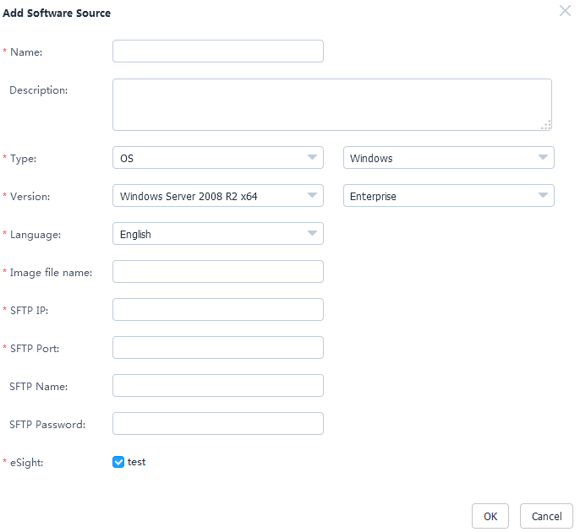

* **Name**: Set this parameter to a customized name. This parameter is used to identify the OS image file.
* **Description**: (Optional) Set this parameter to the customized description of the OS image file.
* **Type**: Select an OS type. The OS types include Windows, SUSE, Red Hat, CentOS, Ubuntu, and VMware ESXi.
* **Version**: Select an OS version. For details, see Table 3-1.
* **Language**: Select a language. This parameter needs to be set only when the OS type is Windows. Select **Chinese** or **English**.
* **Image file name**: Enter the name of the image file on the SFTP server.
* **SFTP IP**: Enter the SFTP server IP address.
* **SFTP Port**: Enter the SFTP server port number.
* **SFTP Name**: Enter the SFTP server user name.
* **SFTP Password**: Enter the SFTP server password.
* **eSight**: Select the eSight of the OS image file to be added. You can select multiple eSight systems at the same time.

Supported software source versions

| Software Source Type | Software Source Version |
| --- | --- |
| Windows | Windows Server 2008 R2 x64 |
| Windows Server 2008 R2 SP1 x64 |
| Windows Server 2012 x64 |
| Windows Server 2012 R2 x64 |
| Windows Server 2016 x64 |
| SUSE | SUSE Linux Enterprise 11 SP1 x64 |
| SUSE Linux Enterprise 11 SP2 x64 |
| SUSE Linux Enterprise 11 SP3 x64 |
| SUSE Linux Enterprise 11 SP4 x64 |
| SUSE Linux Enterprise 12 SP1 x64 |
| SUSE Linux Enterprise 12 x64 |
| Red Hat | Red Hat Linux Enterprise 6.1 x64 |
| Red Hat Linux Enterprise 6.2 x64 |
| Red Hat Linux Enterprise 6.3 x64 |
| Red Hat Linux Enterprise 6.4 x64 |
| Red Hat Linux Enterprise 6.5 x64 |
| Red Hat Linux Enterprise 6.6 x64 |
| Red Hat Linux Enterprise 6.7 x64 |
| Red Hat Linux Enterprise 6.8 x64 |
| Red Hat Linux Enterprise 7.0 x64 |
| Red Hat Linux Enterprise 7.1 x64 |
| Red Hat Linux Enterprise 7.2 x64 |
| CentOS | CentOS Linux Enterprise 6.2 x64 |
| CentOS Linux Enterprise 6.3 x64 |
| CentOS Linux Enterprise 6.4 x64 |
| CentOS Linux Enterprise 6.5 x64 |
| CentOS Linux Enterprise 6.6 x64 |
| CentOS Linux Enterprise 6.7 x64 |
| CentOS Linux Enterprise 7.0 x64 |
| CentOS Linux Enterprise 7.1 x64 |
| CentOS Linux Enterprise 7.2 x64 |
| Ubuntu | Ubuntu Linux Enterprise 14.04 x64 |
| VMWare ESXi | VMWare ESXi 5.0 x64 |
| VMWare ESXi 5.1 x64 |
| VMWare ESXi 5.5 x64 |
| VMWare ESXi 6.0 x64 |

The **Prompt** dialog box is displayed.

Click **OK**.

The software source is added.

On the **Software Source Management** page, view the added software source, as shown in Figure 3-11.

Software Source Management

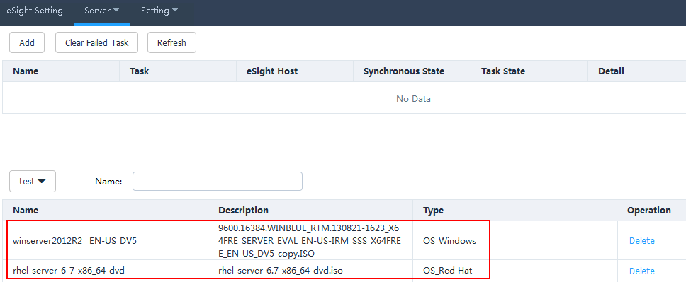

* Click **Refresh** to view the software source uploading progress.
* To delete a software source that fails to be uploaded, click **Clear Failed Task**. All software sources that fail to be uploaded will be deleted.
* To delete a software source that is successfully uploaded, click **Delete** in the row of the software source to be deleted.

----End

#### Creating an OS Template

On the vCenter WebUI, choose **Home** > **Operations and Policies** > **Huawei vCenter Plugin**.

The **Huawei vCenter Plugin** page is displayed.

Choose **Server** > **Template Management**.

The **Template Management** page is displayed.

Click **Create Template**.

The page for creating a template is displayed.

Set the following parameters, as shown in Figure 3-12.

Creating an OS template

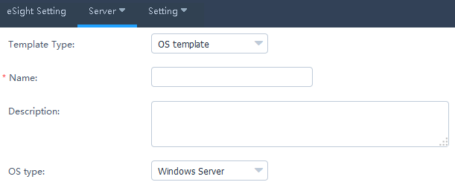

* **Template Type**: Select **OS template**.
* **Name**: Set this parameter to a customized name. This parameter is used to identify the OS template.
* **Description**: (Optional) Set this parameter to customized description, which provides supplementary information for the OS template.
* **OS type**: Select the required OS type.

In the **OS Settings** area, set the following parameters, as shown in Figure 3-13.

OS Settings

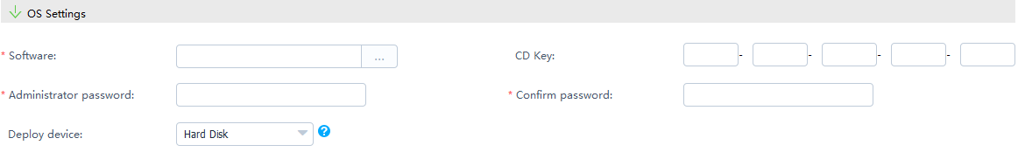

* **Software**: Select the added software source.
* **CD Key**: Enter the OS serial number. This parameter needs to be set only when the OS type is **Windows Server**.
* **Administrator password**: Enter the OS administrator password.
* **Confirm password**: Enter the OS administrator password again.
* **Deploy device**: Select the deployment device based on the actual requirements.



* If the OS type is **VMware ESXi 5.0**, the deployment device is **Hard Disk**.
* If the OS type is **VMware ESXi 5.1/5.5/6.0**, the deployment device is **Hard Disk** or **USB device**.

Set **Partition Settings** only when the OS type is **Windows Server/SUSE Linux/Red Hat/CentOS**, as shown in Figure 3-14.

Partition Settings

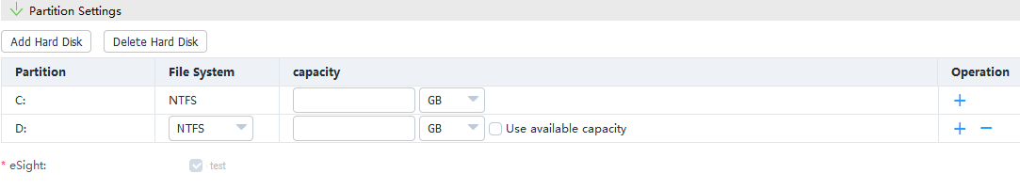

1. Click **Add Hard Disk**.
2. Set **File System**, enter the capacity of the new hard disk, and determine whether to use the remaining capacity based on the actual requirements.



* To add a hard disk partition, click .



* To delete a hard disk partition, click .



* To delete a hard disk, click **Delete Hard Disk**.

Click **OK**.

The **Prompt** dialog box is displayed.

Click **OK**.

The OS template is created.

On the **Template Management** page, view the created OS template, as shown in Figure 3-15.

Template Management

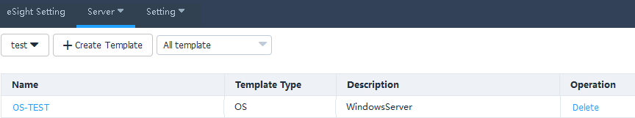

To delete a template, click **Delete** in the row of the template to be deleted.

----End

#### Creating a Template Task

On the vCenter WebUI, choose **Home** > **Operations and Policies** > **Huawei vCenter Plugin**.

The **Huawei vCenter Plugin** page is displayed.

Choose **Server** > **Task Management**.

The **Task Management** page is displayed.

Click **Create Task**.

The page for adding a task is displayed.

Set the following parameters, and click **OK**, as shown in Figure 3-16.

Creating a task

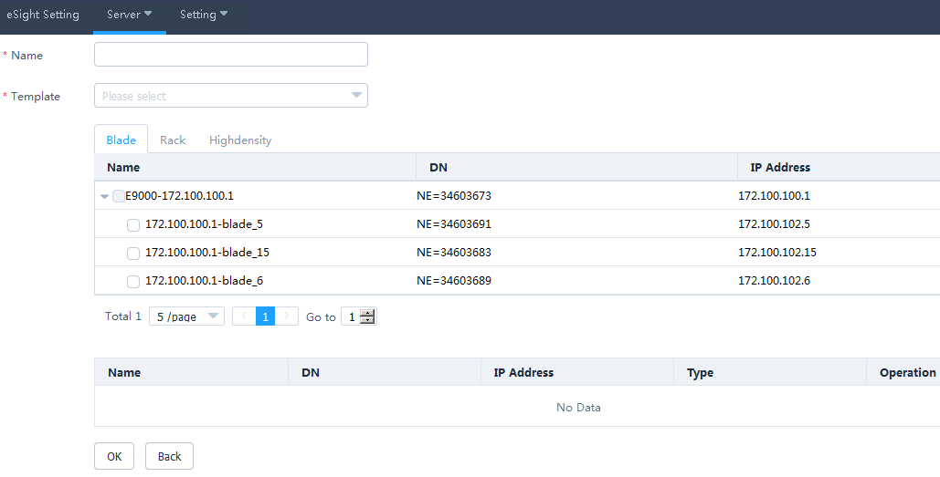

* **Name**: Set this parameter to a customized task name. This parameter is used to identify the task.
* **Template**: Select a created template, and select the server to be added to the template.

The **Prompt** dialog box is displayed.

Click **OK**.

The task is created.

On the **Task Management** page, view the created task, as shown in Figure 3-17.

Task Management

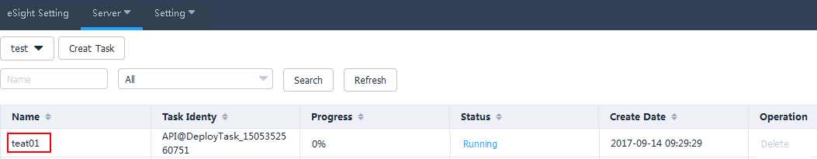

When the value of **Progress** changes to **100%**, click *Status value* in **Status**, and view the template task execution result, as shown in Figure 3-18.

Details about Deployed Devices

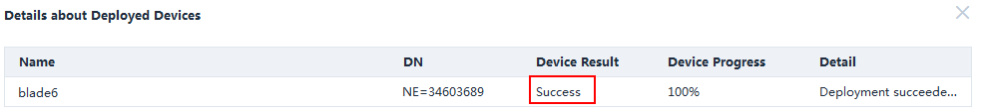

* Click **Refresh** to view the template task progress.
* To delete a template task, click **Delete** in the row of the template task to be deleted.

----End

### Managing Templates

#### Configuring Power Control

On the vCenter WebUI, choose **Home** > **Operations and Policies** > **Huawei vCenter Plugin**.

The **Huawei vCenter Plugin** page is displayed.

Choose **Server** > **Template Management**.

The **Template Management** page is displayed.

Click **Create Template**.

The page for creating a template is displayed.

Set the following parameters, and click **OK**, as shown in Figure 3-19.

Adding a power control template

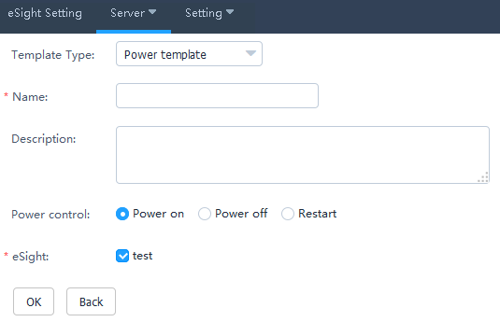

* **Template Type**: Select **Power template**.
* **Name**: Set this parameter to a customized name. This parameter is used to identify the power control template.
* **Description**: (Optional) Set this parameter to customized description, which provides supplementary information for the power control template.
* **Power control**: Select **Power on**, **Power off**, or **Restart**.
* **eSight**: Select the eSight based on the actual requirements. You can select multiple eSight systems.

The **Prompt** dialog box is displayed.

Click **OK**.

The power control template is created.

On the **Template Management** page, view the created power control template.



To delete a template, click **Delete** in the row of the template to be deleted.

Create a template task. For details, see 3.2.2.3 Creating a Template Task.

----End

#### Configuring the BIOS

On the vCenter WebUI, choose **Home** > **Operations and Policies** > **Huawei vCenter Plugin**.

The **Huawei vCenter Plugin** page is displayed.

Choose **Server** > **Template Management**.

The **Template Management** page is displayed.

Click **Create Template**.

The page for creating a template is displayed.

Set the following parameters, as shown in Figure 3-20.

Adding a BIOS template

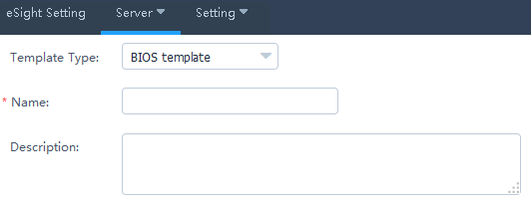

* **Template Type**: Select **BIOS template**.
* **Name**: Set this parameter to a customized name. This parameter is used to identify the BIOS template.
* **Description**: (Optional) Set this parameter to customized description, which provides supplementary information for the BIOS template.

In the **Boot** area, use or to set the system boot sequence.



In the **Virtualization** area, set the parameters described in Table 3-2, as shown in Figure 3-21.

Virtualization



Parameters in the Virtualization area

| Parameter | Description |
| --- | --- |
| VT support | Enables or disables the hardware-assisted virtualization technology.   * **Enabled**: enables the hardware-assisted virtualization technology. * **Disabled**: disables the hardware-assisted virtualization technology. * **Default**: retains the default settings. |
| PCIe SR-IOV | Enables or disables the SR-IOV technology of the PCIe card.   * **Enabled**: enables the SR-IOV technology of the PCIe card. * **Disabled**: disables the SR-IOV technology of the PCIe card. * **Default**: retains the default settings. |

In the **Advanced Processor** area, set the parameters described in Table 3-3, as shown in Figure 3-22.

Advanced Processor

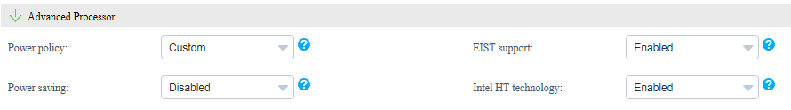

Parameters in the Advanced Processor area

| Parameter | Description |
| --- | --- |
| Power policy | Indicates the power policy.   * **Efficient**: indicates the mode of low performance and low power consumption. This mode can reduce the power consumption of the system. * **Performance**: indicates the mode of high performance and high power consumption. * **Custom**: indicates the mode that reduces the power consumption of most OSs and applications and minimizes the impact on performance. * **Default**: retains the default settings. |
| EIST support | Indicates the intelligent frequency control function.   * **Enabled**: enables the EIST function. * **Disabled**: disables the EIST function. * **Default**: retains the default settings. |
| Power saving | Indicates the CPU P State adjustment function.   * **Enabled**: enables the CPU P State adjustment function. * **Disabled**: disables the CPU P State adjustment function. * **Default**: retains the default settings. |
| Intel HT technology | Indicates the Intel Hyper Threading (HT) technology. This technology enhances CPU performance by increasing the number of CPU kernel threads.   * **Enabled**: enables the CPU HT function. * **Disabled**: disables the CPU HT function. * **Default**: retains the default settings. |

In the **IPMI** area, set the parameters described in Table 3-4, as shown in Figure 3-23.

IPMI



Parameters in the IPMI area

| Parameter | Description |
| --- | --- |
| Restore on AC Power Loss | Indicates the restoration mode used by the BMC after AC power-off.   * **Power OFF**: powers off the system. * **Last State**: restores the system to the last state. * **Power ON**: powers on the system. * **Default**: retains the default settings. |

Click **Advanced**.

The **Advanced Settings** dialog box is displayed.

In the **Boot** area, set the parameters described in Table 3-5, as shown in Figure 3-24.

Boot

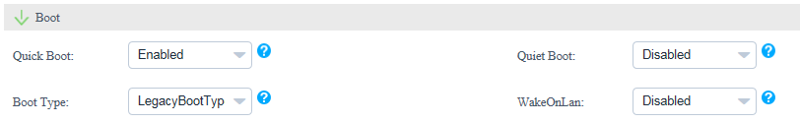

Parameters in the Boot area

| Parameter | Description |
| --- | --- |
| Quick Boot | Indicates the quick boot mode.   * **Enabled**: enables the quick boot mode. * **Disabled**: disables the quick boot mode. * **Default**: retains the default settings. |
| Quiet Boot | Indicates the quiet boot mode.   * **Enabled**: enables the quiet boot mode. * **Disabled**: disables the quiet boot mode. * **Default**: retains the default settings. |
| Boot Type | Indicates the system boot mode.   * **Dual Boot Type**: supports both the Legacy boot mode and the UEFI boot mode. * **Legacy Boot Type**: supports only the Legacy boot mode. * **UEFI Boot Type**: supports only the UEFI boot mode. * **Default**: retains the default settings. |
| WakeOnLan | Indicates the remote startup of a server when it receives a special data packet.   * **Enabled**: enables the Wake On Lan function. * **Disabled**: disables the Wake On Lan function. * **Default**: retains the default settings. |

In the **Virtualization** area, set the parameters described in Table 3-6, as shown in Figure 3-25.

Virtualization

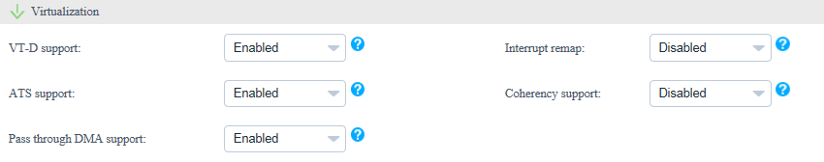

Parameters in the Virtualization area

| Parameter | Description |
| --- | --- |
| VT-D support | Indicates the direct I/O virtualization function.   * **Enabled**: enables the direct I/O virtualization function. * **Disabled**: disables the direct I/O virtualization function. * **Default**: retains the default settings. |
| Interrupt remap | Indicates the interrupt remapping function.   * **Enabled**: enables the interrupt remapping function. * **Disabled**: disables the interrupt remapping function. * **Default**: retains the default settings. |
| ATS support | Indicates the ATS function.   * **Enabled**: enables the ATS function. * **Disabled**: disables the ATS function. * **Default**: retains the default settings. |
| Coherency support | Indicates the Coherency Support function.   * **Enabled**: enables the Coherency Support function. * **Disabled**: disables the Coherency Support function. * **Default**: retains the default settings. |
| Pass through DMA support | Indicates the PassThrough DMA function.   * **Enabled**: enables the PassThrough DMA function. * **Disabled**: disables the PassThrough DMA function. * **Default**: retains the default settings. |

In the **Advanced Processor** area, set the parameters described in Table 3-7, as shown in Figure 3-26.

Advanced Processor

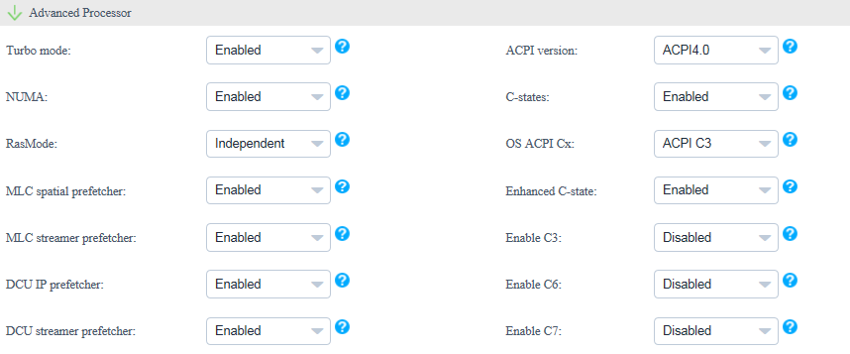

Parameters in the Advanced Processor area

| Parameter | Description |
| --- | --- |
| Turbo mode | Indicates the dynamic acceleration function.   * **Enabled**: enables the dynamic acceleration function. * **Disabled**: disables the dynamic acceleration function. * **Default**: retains the default settings. |
| ACPI version | Indicates the ACPI version.   * **ACPI1.0B**: ACPI1.0B version * **ACPI3.0**: ACPI3.0 version * **ACPI4.0**: ACPI4.0 version * **Default**: retains the default settings. |
| NUMA | Indicates the non-uniform memory access (NUMA) function.   * **Enabled**: enables the NUMA function. * **Disabled**: disables the NUMA function. * **Default**: retains the default settings. |
| C-states | Indicates the CPU C status control function.   * **Enabled**: enables the CPU C status control function. * **Disabled**: disables the CPU C status control function. * **Default**: retains the default settings. |
| RasMode | Indicates the memory RAS mode.   * Independent * Mirror * LockStep * RankSpare * LockStepAndRankSpare * Default |
| OS ACPI Cx | Indicates the Advanced Configuration and Power Interface (ACPI) C-state of the OS. The OS instructs a CPU to enter the C-state based on the ACPI C-state.   * ACPI C2 * ACPI C3 * Default |
| MLC spatial prefetcher | Indicates the Mid Level Cache (MLC) Spatial prefetcher function.   * **Enabled**: enables the MLC Spatial prefetcher function. * **Disabled**: disables the MLC Spatial prefetcher function. * **Default**: retains the default settings. |
| Enhanced C-state | Indicates the C-state function.   * **Enabled**: enables the C-state function. * **Disabled**: disables the C-state function. * **Default**: retains the default settings. |
| MLC streamer prefetcher | Indicates the MLC Streamer prefetcher function.   * **Enabled**: enables the MLC Streamer prefetcher function. * **Disabled**: disables the MLC Streamer prefetcher function. * **Default**: retains the default settings. |
| Enable C3 | Indicates the C3 function.   * **Enabled**: enables the C3 function. * **Disabled**: disables the C3 function. * **Default**: retains the default settings. |
| DCU IP prefetcher | Indicates the data cache unit (DCU) IP prefetcher function. This function determines whether to prefetch data based on historical records. This function is enabled by default. You can enable or disable this function based on the applications running on the server. This function can affect performance and shorten the data reading time.   * **Enabled**: enables the DCU IP prefetcher function. * **Disabled**: disables the DCU IP prefetcher function. * **Default**: retains the default settings. |
| Enable C6 | Indicates the C6 function.   * **Enabled**: enables the C6 function. * **Disabled**: disables the C6 function. * **Default**: retains the default settings. |
| DCU streamer prefetcher | Indicates the DCU streamer prefetcher function. This function can be used to preread CPU data. This function is enabled by default. You can enable or disable this function based on the applications running on the server. This function can affect performance and shorten the data reading time.   * **Enabled**: enables the DCU streamer prefetcher function. * **Disabled**: disables the DCU streamer prefetcher function. * **Default**: retains the default settings. |
| Enable C7 | Indicates the C7 function.   * **Enabled**: enables the C7 function. * **Disabled**: disables the C7 function. * **Default**: retains the default settings. |

In the **Console Serial Port** area, set the parameters described in Table 3-8, as shown in Figure 3-27.

Console Serial Port

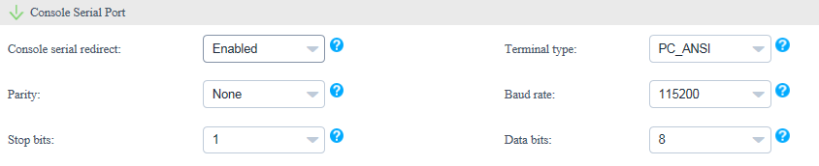

Parameters in the Console Serial Port area

| Parameter | Description |
| --- | --- |
| Console serial redirect | Indicates the serial port redirection function.   * **Enabled**: enables the serial port redirection function. * **Disabled**: disables the serial port redirection function. * **Default**: retains the default settings. |
| Terminal type | Indicates the terminal protocol.   * VT_100 * VT_100+ * VT_UTF8 * PC_ANSI * Default |
| Parity | Indicates the parity check function.   * **None**: indicates no parity check. * **Even**: indicates the even parity check. * **Odd**: indicates the odd parity check. * **Default**: retains the default settings. |
| Baud rate | Indicates the serial port redirection speed.   * 115200 * 57600 * 19200 * 9600 * Default |
| Stop bits | Indicates the stop bit for the serial port redirection function.   * 1 * 2 * Default |
| Data bits | Indicates the data bit length for the serial port redirection function.   * 7 * 8 * Default |

In the **IPMI** area, set the parameters described in Table 3-9, as shown in Figure 3-28.

IPMI

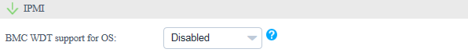

Parameters in the IPMI area

| Parameter | Description |
| --- | --- |
| BMC WDT support for OS | Indicates the watchdog during the OS startup process.   * **Enabled**: enables the watchdog during the OS startup process. * **Disabled**: disables the watchdog during the OS startup process. * **Default**: retains the default settings. |

Click **OK**.

Select the eSight to which the BIOS template is to be added, and click **OK**. (You can select multiple eSight systems.)

The **Prompt** dialog box is displayed.

Click **OK**.

The BIOS template is created.

On the **Template Management** page, view the created BIOS template.



To delete a template, click **Delete** in the row of the template to be deleted.

Create a template task. For details, see 3.2.2.3 Creating a Template Task.

----End

#### Configuring an HBA

On the vCenter WebUI, choose **Home** > **Operations and Policies** > **Huawei vCenter Plugin**.

The **Huawei vCenter Plugin** page is displayed.

Choose **Server** > **Template Management**.

The **Template Management** page is displayed.

Click **Create Template**.

The page for creating a template is displayed.

Set the following parameters, as shown in Figure 3-29.

Adding an HBA template

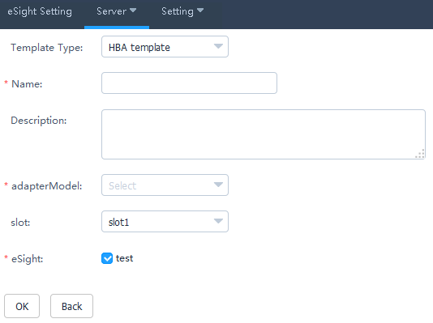

* **Template Type**: Select **HBA template**.
* **Name**: Set this parameter to a customized name. This parameter is used to identify the HBA template.
* **Description**: (Optional) Set this parameter to customized description, which provides supplementary information for the HBA template.
* **Adapter Model**: Select the HBA model.
* **slot**: Select the HBA slot number.
* **eSight**: Select the eSight based on the actual requirements. You can select multiple eSight systems.

In the port area, click **Advanced**.

The **Advanced** dialog box is displayed.

Set the following parameters, and click **OK**, as shown in Figure 3-30.

Advanced

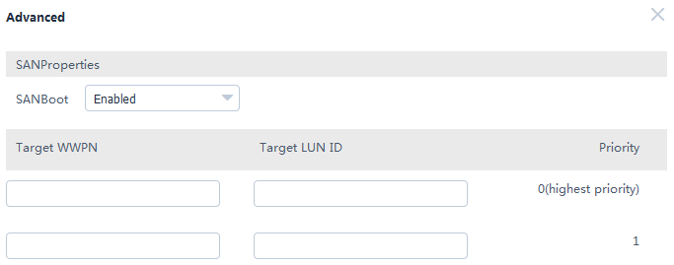

* **SAN boot**: Select **Enabled** or **Disabled**.
* **Target WWPN**: This parameter needs to be set only when **SAN boot** is set to **Enabled**.
* **Target LUN ID**: This parameter needs to be set only when **SAN boot** is set to **Enabled**.
* **Target WWNN**: This parameter needs to be set only when **SAN boot** is set to **Enabled** and **Adapter Model** is set to **QLE2560** or **QLE2562**.

Click **OK**.

The **Prompt** dialog box is displayed.

Click **OK**.

The HBA template is created.

On the **Template Management** page, view the created HBA template.



To delete a template, click **Delete** in the row of the template to be deleted.

Create a template task. For details, see 3.2.2.3 Creating a Template Task.

----End

#### Configuring RAID

On the vCenter WebUI, choose **Home** > **Operations and Policies** > **Huawei vCenter Plugin**.

The **Huawei vCenter Plugin** page is displayed.

Choose **Server** > **Template Management**.

The **Template Management** page is displayed.

Click **Create Template**.

The page for creating a template is displayed.

Set the following parameters, as shown in Figure 3-31.

Adding a RAID template

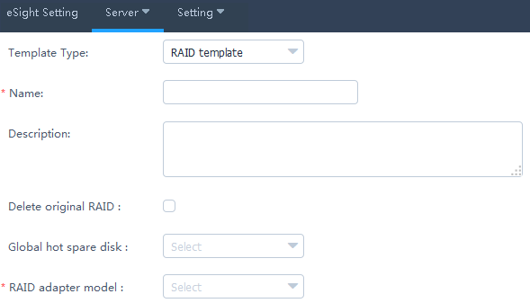

* **Template Type**: Select **RAID template**.
* **Name**: Set this parameter to a customized name. This parameter is used to identify the RAID template.
* **Description**: (Optional) Set this parameter to customized description, which provides supplementary information for the RAID template.
* **Delete original RAID**: This parameter is deselected by default. Determine whether to select this parameter based on the actual situation.
* **Global hot spare disk**: (Optional) This parameter is not set by default. Select the slot number of the hard disk to be set to a global hot spare disk. You can select multiple slot numbers.
* **RAID adapter model**: Select the model of the RAID adapter to be configured.

In the **RAID Group** area, click **Create**.

The **Create RAID Group** dialog box is displayed.

Set the following parameters, and click **OK**, as shown in Figure 3-32.

Create RAID Group

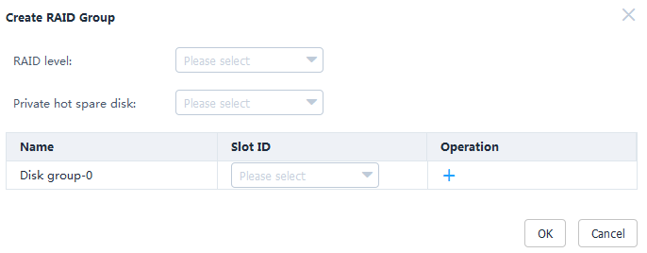

* **RAID level**: Select the RAID level to be configured.
* **Private hot spare disk**: (Optional) This parameter is not set by default. Select the slot number of the hard disk to be set to a private hot spare disk. You can select multiple slot numbers.



* Private hot spare disks cannot be configured for RAID 0.
* Private hot spare disks cannot be configured for LSI SAS2308 and LSI SAS3008.
* **Disk group-0**: Select the slot number of the hard disk to be added to the hard disk group.



Only one disk group can be created for RAID 0, RAID 1, RAID 5, RAID 6, and RAID 1E.

(Optional) Retain the default value **0** for **Start LUN ID**.

Click **OK**.

The **Prompt** dialog box is displayed.

Click **OK**.

The RAID template is created.

On the **Template Management** page, view the created RAID template.



To delete a template, click **Delete** in the row of the template to be deleted.

Create a template task. For details, see 3.2.2.3 Creating a Template Task.

----End

#### Configuring a CNA

On the vCenter WebUI, choose **Home** > **Operations and Policies** > **Huawei vCenter Plugin**.

The **Huawei vCenter Plugin** page is displayed.

Choose **Server** > **Template Management**.

The **Template Management** page is displayed.

Click **Create Template**.

The page for creating a template is displayed.

Set the following parameters, as shown in Figure 3-33.

Adding a CNA template

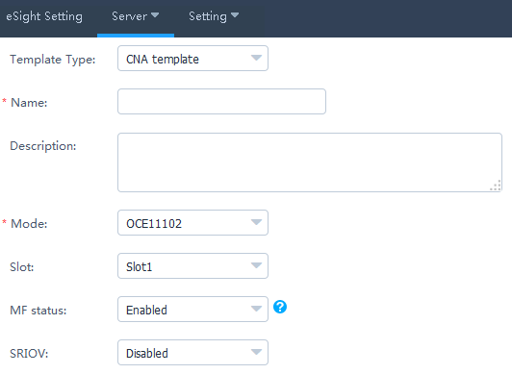

* **Template Type**: Select **CNA template**.
* **Name**: Set this parameter to a customized name. This parameter is used to identify the CNA template.
* **Description**: (Optional) Set this parameter to customized description, which provides supplementary information for the CNA template.
* **Mode**: Select the CNA model.
* **Slot**: (Optional) Select the CNA slot number.
* **MF status**: (Optional) This parameter needs to be set only when **Mode** is set to **OCE11102**, **MZ510**, or **MZ512**. Determine whether to enable MF based on the actual situation.
* **SRIOV**: (Optional) This parameter needs to be set only when **Mode** is set to **OCE11102**, **MZ510**, or **MZ512**. Determine whether to enable SRIOV based on the actual situation.



MF and SRIOV cannot be enabled at the same time.

Check whether **Mode** is set to **MZ910**.

* If yes, perform Step 6 and Step 7.
* If no, go to Step 8.

In the port area, click **Advanced**.

The **Advanced** dialog box is displayed.

Enable or disable **PXE boot**, and click **OK**.

Then go to Step 11.

In the port area, set the parameters described in Table 3-10.

Port0

| Parameter | Description |
| --- | --- |
| PF type | * NIC * iSCSI * FCoE   NOTE  **iSCSI** and **FCoE** are available only for PF1. |
| PF VLAN ID | This parameter needs to be set if **PF type** is set to **NIC**. Enter a VLAN ID based on the actual situation. |

In the port area, click **Advanced**.

The **Advanced** dialog box is displayed.

Set the parameters described in Table 3-11, as shown in Figure 3-34.

Advanced

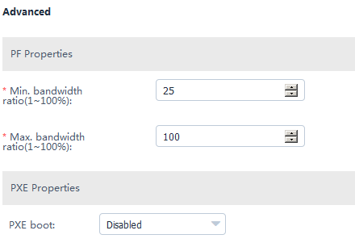

Parameters in the Advanced dialog box

| Parameter | Description |
| --- | --- |
| Min. bandwidth ratio | Indicates the minimum bandwidth ratio of a single virtual network port. |
| Max. bandwidth ratio | Indicates the maximum bandwidth ratio of a single virtual network port. |
| PXE boot | This parameter can be set to **Enabled** or **Disabled**. |

Click **OK**.

The **Prompt** dialog box is displayed.

Click **OK**.

The CNA template is created.

On the **Template Management** page, view the created CNA template.



To delete a template, click **Delete** in the row of the template to be deleted.

Create a template task. For details, see 3.2.2.3 Creating a Template Task.

----End

#### Configuring the iBMC

On the vCenter WebUI, choose **Home** > **Operations and Policies** > **Huawei vCenter Plugin**.

The **Huawei vCenter Plugin** page is displayed.

Choose **Server** > **Template Management**.

The **Template Management** page is displayed.

Click **Create Template**.

The page for creating a template is displayed.

Set the following parameters, as shown in Figure 3-35.

Adding an iBMC template

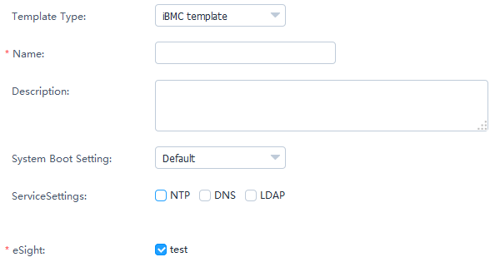

* **Template Type**: Select **iBMC template**.
* **Name**: Set this parameter to a customized name. This parameter is used to identify the iBMC template.
* **Description**: (Optional) Set this parameter to customized description, which provides supplementary information for the iBMC template.
* **System Boot Setting**: Select a system boot option based on the actual situation.
* **Service Settings**: Select a service setting option based on the actual situation. You can select multiple options. After **NTP**, **DNS**, or **LDAP** is selected, the related parameters need to be set.
* **eSight**: Select the eSight based on the actual requirements. You can select multiple eSight systems.

In the **NTP** area, set the parameters described in Table 3-12, as shown in Figure 3-36.

NTP

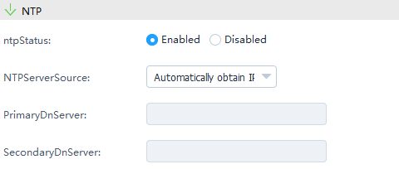

Parameters in the NTP area

| Parameter | Description |
| --- | --- |
| NTP Status | Enable or disable NTP.   * Enabled * Disabled |
| NTP Server Source | Select the NTP server source obtaining mode.   * Automatically obtain IPv4 * Automatically obtain IPv6 * Manually obtain |
| Primary NTP Server | (Optional) Enter the preferred NTP server IP address only when the NTP server source is obtained manually. |
| Secondary NTP Server | (Optional) Enter the alternate NTP server IP address only when the NTP server source is obtained manually. |

In the **DNS** area, set the parameters described in Table 3-13.

Parameters in the DNS area

| Parameter | Description |
| --- | --- |
| DNS Source | Select the DNS obtaining mode.   * Automatically Obtain * Manually Set |
| Domain Name | (Optional) Set the domain name only when the DNS is set manually. |
| Primary DNS Server | (Optional) Set the preferred DNS server IP address only when the DNS is set manually. |
| Secondary DNS Server | (Optional) Set the alternate DNS server IP address only when the DNS is set manually. |

In the **LDAP** area, set the parameters described in Table 3-14, as shown in Figure 3-37.

LDAP

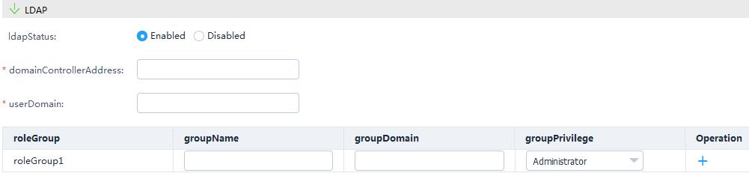

Parameters in the LDAP area

| Parameter | Description |
| --- | --- |
| LDAP Status | Select the LDAP status.   * Enabled * Disabled |
| Domain Controller Address | (Optional) Set the domain controller address only when LDAP is enabled. |
| User Domain | (Optional) Set the user domain only when LDAP is enabled. |
| Role Group | (Optional) Set the group name, group domain, and group privilege only when LDAP is enabled.  NOTE  You need to configure at least one role group. A maximum of five role groups can be configured. |

Click **OK**.

The **Prompt** dialog box is displayed.

Click **OK**.

The iBMC template is created.

On the **Template Management** page, view the created iBMC template.



To delete a template, click **Delete** in the row of the template to be deleted.

Create a template task. For details, see 3.2.2.3 Creating a Template Task.

----End

### Upgrading the Firmware and Driver

#### Uploading an Upgrade Package

Upload an upgrade package file to the SFTP server.

On the vCenter WebUI, choose **Home** > **Operations and Policies** > **Huawei vCenter Plugin**.

The **Huawei vCenter Plugin** page is displayed.

Choose **Server** > **Firmware Upload**.

The **Firmware Upload** page is displayed.

Click **Add**.

The page for adding a file is displayed.

Set the following parameters, and click **OK**, as shown in Figure 3-38.

Uploading an upgrade package

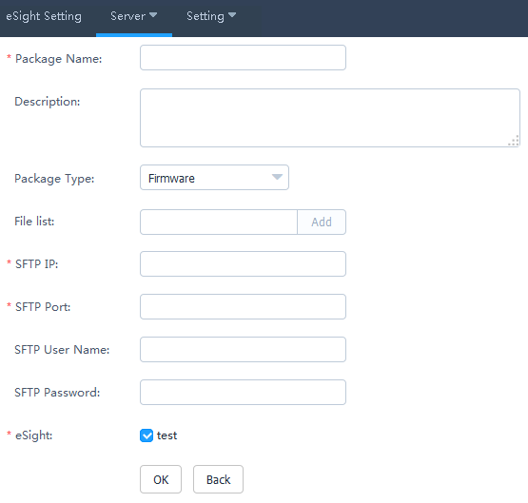

* **Package Name**: Set this parameter to a customized upgrade package name. This parameter is used to identify the upgrade package.
* **Description**: Set this parameter to customized description, which provides supplementary information for the upgrade package.
* **Package Type**: Select **Firmware**, **Driver**, or **Bundle**.
* **File list**: Click **Add**, and select the upgrade package file.



You need to upload the ZIP package and digital signature certificate if **Package Type** is set to **Firmware** or **Driver**. You need to upload only the ZIP package if **Package Type** is set to **Bundle**.

* **SFTP IP**: Enter the SFTP server IP address.
* **SFTP Port**: Enter the SFTP server port number.
* **SFTP User Name**: Enter the SFTP server user name.
* **SFTP Password**: Enter the SFTP server password.
* **eSight**: Select the eSight based on the actual requirements. You can select multiple eSight systems.

The **Prompt** dialog box is displayed.

Click **OK**.

The firmware uploading task is created.

On the **Firmware Upload** page, view the created firmware uploading task, as shown in Figure 3-39.

Firmware Upload

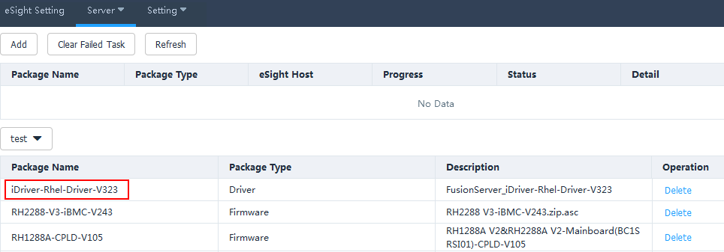

* Click **Refresh** to view the firmware uploading progress.
* When the value of **Progress** changes to **100%**, view *Status value* in **Status** to check whether the upgrade package is successfully uploaded.
* To delete an upgrade package that fails to be uploaded, click **Clear Failed Task**. All upgrade packages that fail to be uploaded will be deleted.
* To delete an upgrade package that is successfully uploaded, click **Delete** in the row of the upgrade package to be deleted.

----End

#### Upgrading the Firmware and Driver

On the vCenter WebUI, choose **Home** > **Operations and Policies** > **Huawei vCenter Plugin**.

The **Huawei vCenter Plugin** page is displayed.

Choose **Server** > **Firmware Upgrade**.

The **Firmware Upgrade** page is displayed.

Click **Create Task**.

The page for adding a task is displayed.

Set the following information, and click **OK**, as shown in Figure 3-40.

Creating an upgrade task

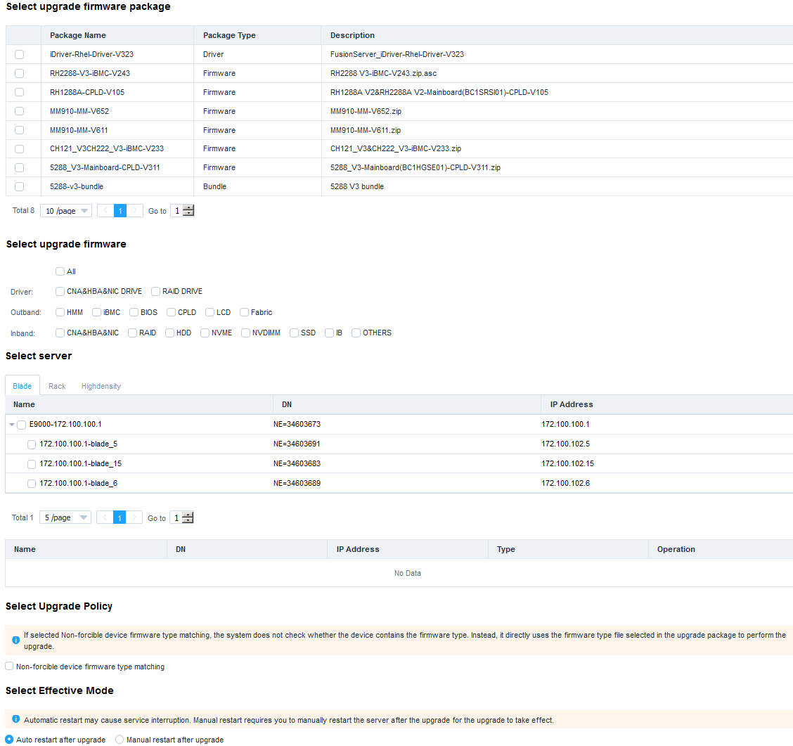

* **Select upgrade firmware package**: Select the name of the firmware package to be upgraded.
* **Select upgrade firmware**: Select the firmware to be upgraded.
* **Select server**: Select the server to be upgraded.
* **Select Upgrade Policy**: **Non-forcible device firmware type matching** is deselected by default.
* **Select Effective Mode**: **Auto restart after upgrade** is selected by default.

The **Prompt** dialog box is displayed.

Click **OK**.

The upgrade task is created.

On the **Firmware Upgrade** page, view the created firmware upgrade task, as shown in Figure 3-41.

Firmware Upgrade

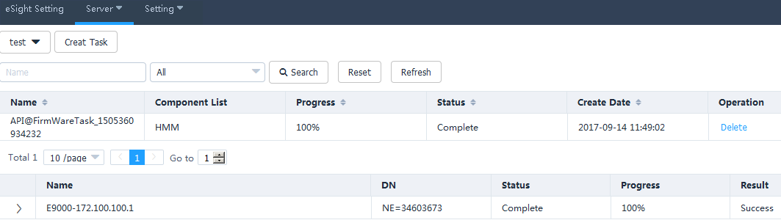

* Click **Refresh** to view the firmware and driver upgrade progress.
* When the value of **Progress** changes to **100%**, click *Status value* in **Status**, and view the firmware and driver upgrade result.
* To delete a firmware and driver upgrade task, click **Delete** in the row of the firmware and driver upgrade task to be deleted.

----End

### Registering, Configuring, and Using Proactive HA

#### Registering HA Provider



* Ensure that the target server is in the cluster.
* Ensure that the target server is added to eSight and eSight is added to the Huawei vCenter plug-in.
* After HA Provider is registered, if you need to add another host to the cluster, you need to add it to **Datacenter**, register HA Provider again, and move the host to the cluster.

On the vCenter WebUI, choose **Home** > **Operations and Policies** > **Huawei vCenter Plugin**.

The **Huawei vCenter Plugin** page is displayed, as shown in Figure 3-42.

Huawei vCenter plug-in

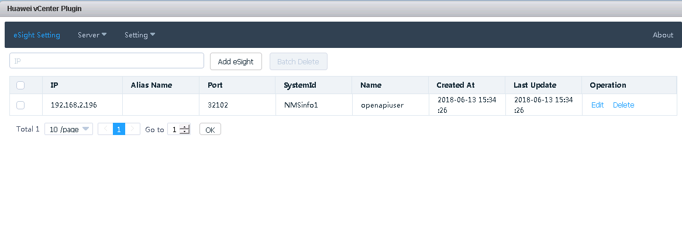

Choose **Setting** > **HA Setting**.

The page for registering HA Provider is displayed, as shown in Figure 3-43.

Registering HA Provider

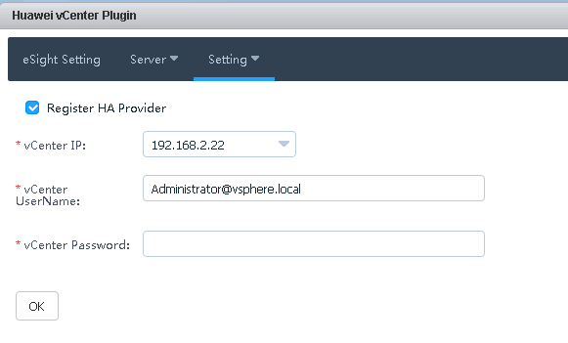

Select **Register HA Provider**, enter the IP address, user name, and password of the current vCenter, and click **OK**.

The HA Provider registration starts. After the registration is successful, a dialog box is displayed, as shown in Figure 3-44.

Successful registration

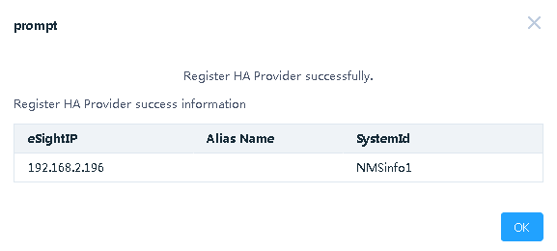

Click **OK**.

HA Provider is registered.

----End

#### Configuring Proactive HA

On the vCenter WebUI, choose **Home** > **Inventories** > **Hosts and Clusters**.

The **Hosts and Clusters** page is displayed.

Click the cluster where the target host is located, and click **Configure**.

The page for configuring Proactive HA is displayed, as shown in Figure 3-45.

Configuring Proactive HA

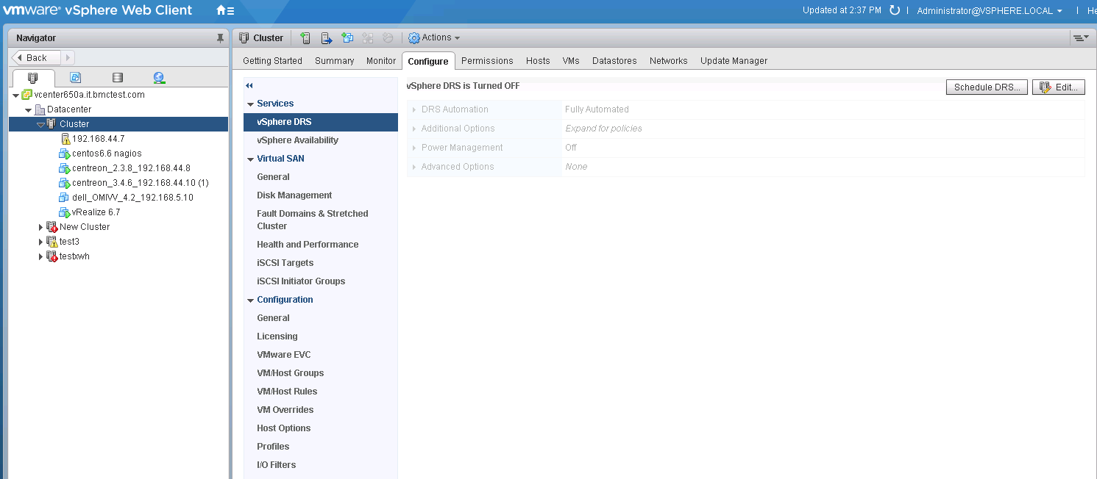

Click **Edit** in the upper right corner.

The **Edit Cluster Setting** page is displayed, as shown in Figure 3-46.

Edit Cluster Setting

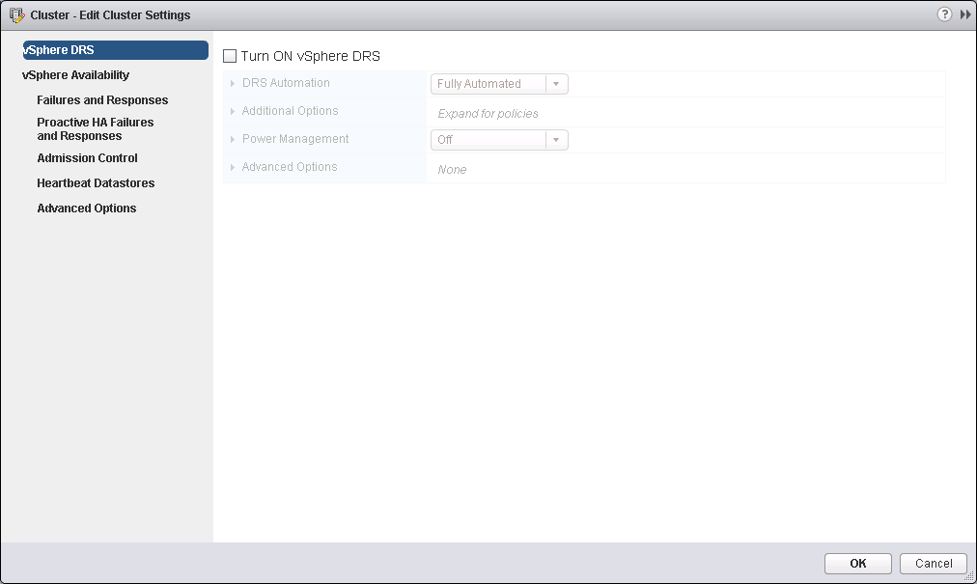

Select **Turn ON vSphere DRS**.

Click **vSphere Availability**.

The **vSphere Availability** page is displayed, as shown in Figure 3-47.

vSphere Availability

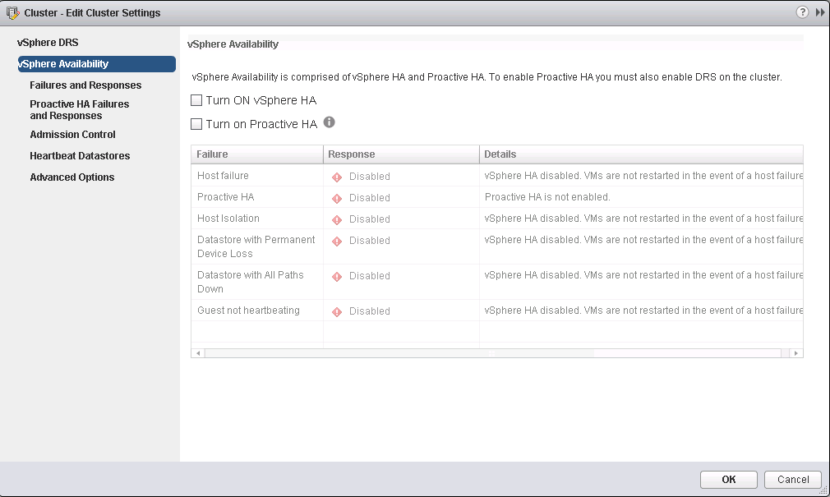

Select **Turn ON vSphere HA** and **Turn on Proactive HA**.

Click **Failures and Responses**.

The **Failures and Responses** page is displayed, as shown in Figure 3-48.

Failures and Responses

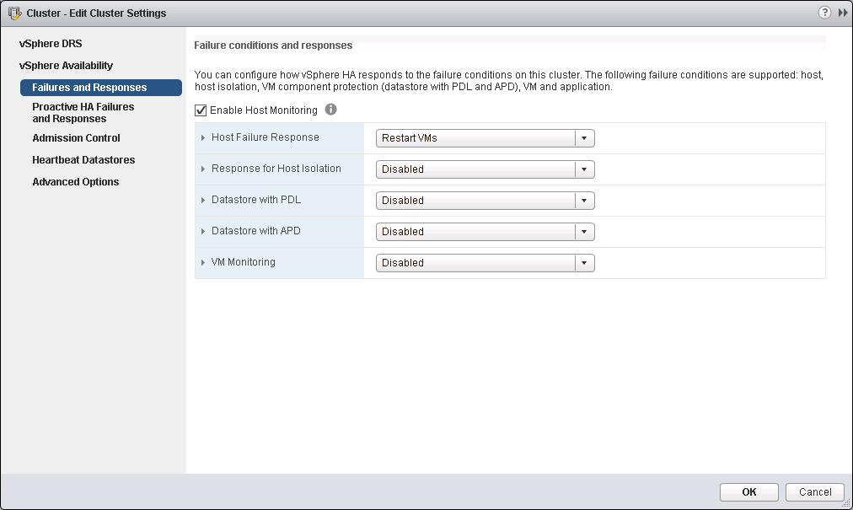

Select **Enable Host Monitoring**.

Click **Proactive HA Failures and Responses**.

The **Proactive HA Failures and Responses** page is displayed, as shown in Figure 3-49.

Proactive HA Failures and Responses

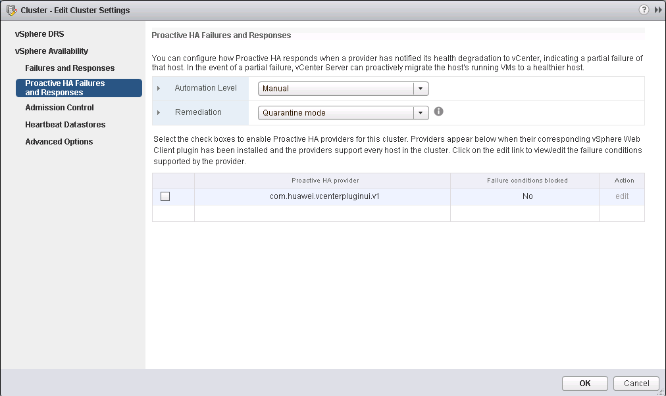

In the **Proactive HA provider** table, select the provider program **com.huawei.vcenterpluginui.v1** provided by the Huawei vCenter plug-in, and click **OK**.

Proactive HA is configured.

----End

#### Using Proactive HA

On the vCenter WebUI, choose **Home** > **Inventories** > **Hosts and Clusters**.

The **Hosts and Clusters** page is displayed.

Choose **Datacenter** > **Cluster** > *Host*.

The host page is displayed, as shown in Figure 3-50.

Host

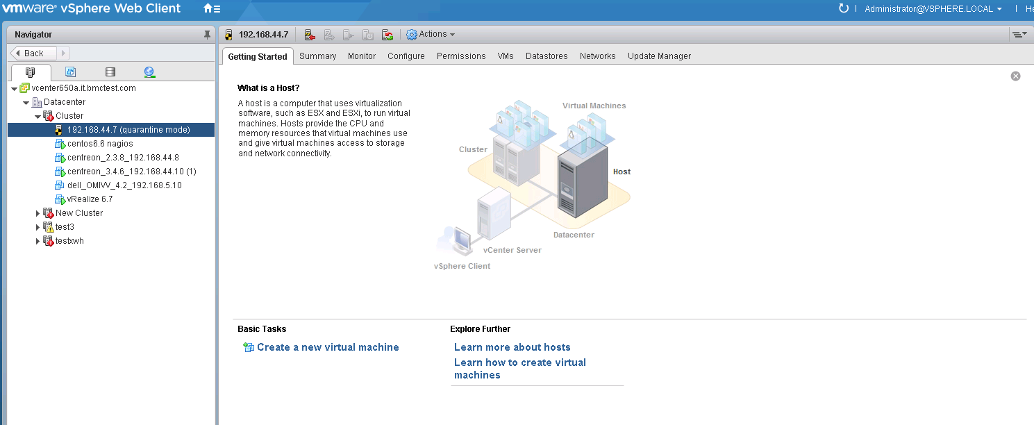

Choose **Monitor** > **Tasks & Events** > **Events**.

The event page of the server is displayed, as shown in Figure 3-51. You can view the alarms pushed by HA Provider. The alarm description is started with the HA Provider name.

Events

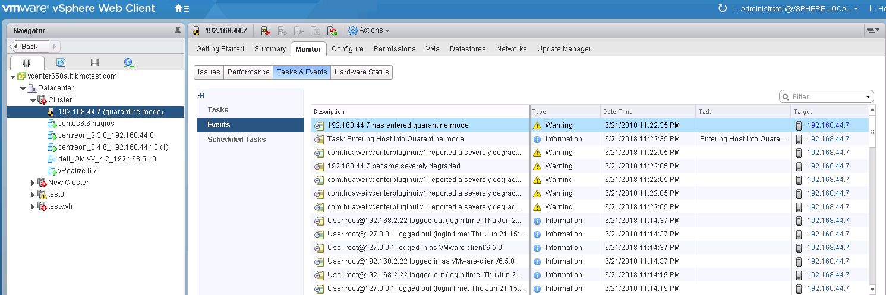

If **Automation Level** is set to **Automated** and **Remediation** is set to **Quarantine mode** in 3.2.5.2 Configuring Proactive HA, as shown in Figure 3-52, when the alarms pushed by HA Provider are severely degraded, vCenter will isolate the host.

Configuring Proactive HA

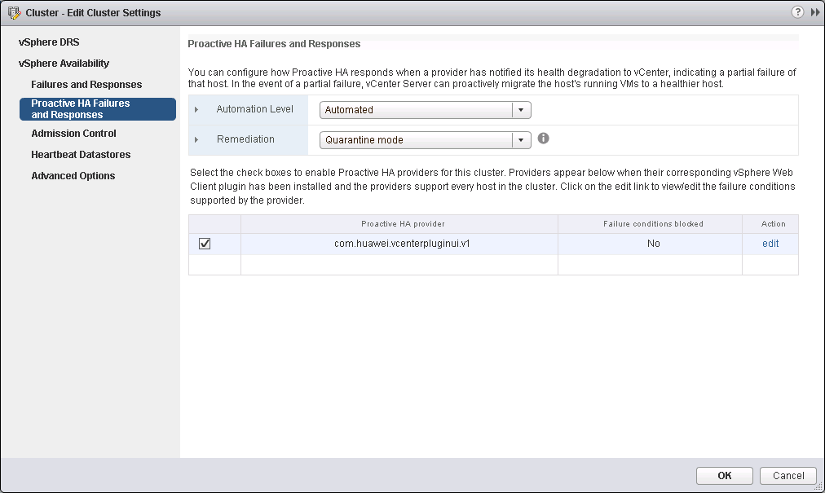

----End

### Receiving and Viewing Server Alarms

On the vCenter WebUI, choose **Home** > **Operations and Policies** > **Huawei vCenter Plugin**.

The **Huawei vCenter Plugin** page is displayed.

Choose **Setting** > **Basic Setting**.

The Basic Setting page is displayed, as shown in Figure 3-53.

Enter basic information.

Basic Setting

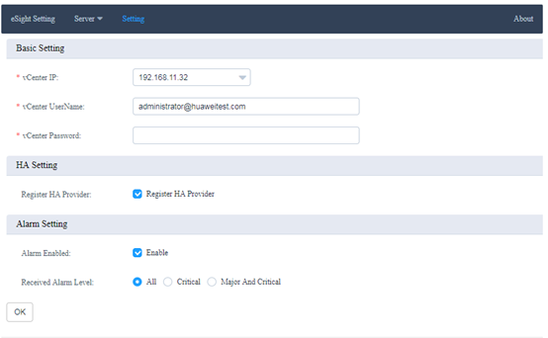

**Basic Setting**

* **vCenter IP:** Enter the vCenter IP address.
* **vCenter UserName:** Enter the vCenter administrator user name.
* **vCenter Password:** Enter the vCenter administrator password.

**Alarm Setting**

* **Alarm Enabled:** Determine whether to receive alarms.
* **Received Alarm Level:**
* **All:** Receive all events and alarms.
* **Critical:** Receive critical events and alarms.
* **Major And Critical:** Receive critical and major events and alarms.

Click **OK**. After information indicating that the configuration is successful is diaplayed, go to Step 4.

On the vCenter WebUI, choose **Home** > **Inventories** > **Hosts and Clusters**.

The **Hosts and Clusters** page is displayed.

Click the cluster where the target host is located to view events and alarms.

* Choose **Monitor** > **Task & Events** to view server events.

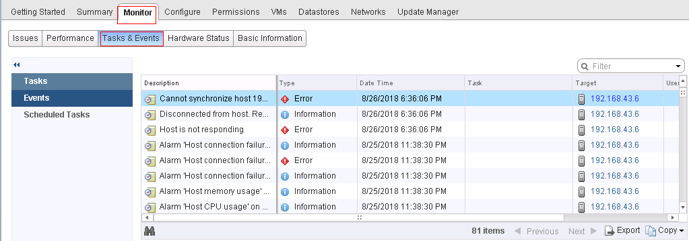

* Choose **Monitor** > **Issues**.

The problem description, alarm type, triggering time, and status information is displayed in the list.

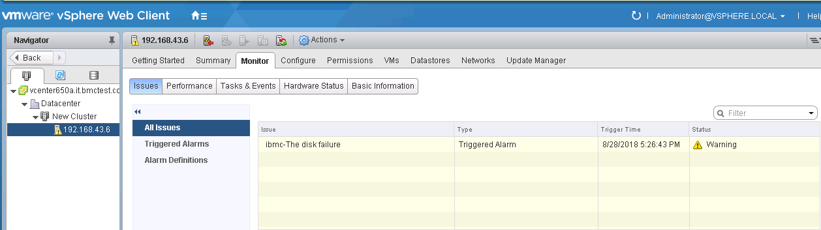

Click **Triggered Alarms**, and click the name of an alarm in the right list to view detailed alarm information.

Triggered Alarms

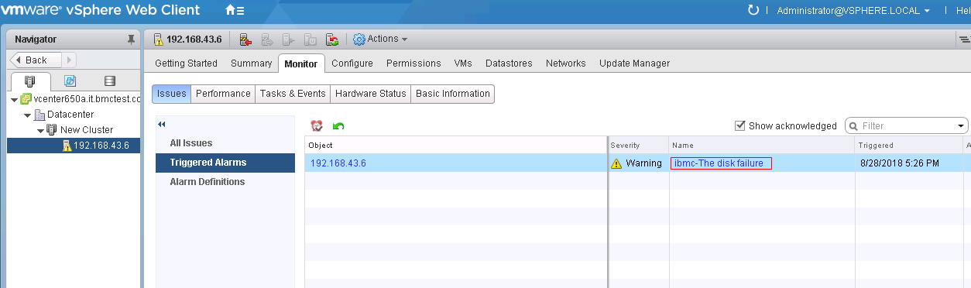

Detailed alarm information

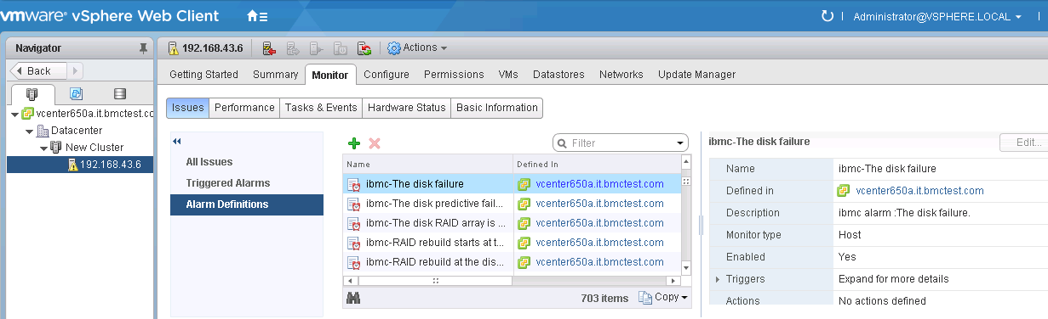

----End

## Viewing the Huawei vCenter Plug-in Version

On the vCenter WebUI, choose **Home** > **Operations and Policies** > **Huawei vCenter Plugin**.

The **Huawei vCenter Plugin** page is displayed.

Click **About**.

View the Huawei vCenter plug-in version, as shown in Figure 3-56.

Huawei vCenter plug-in version



----End